The Carmel Street Art Gallery wishes to maintain data on all of their customers, artists and paintings that they offer. It is typical that they will have several paintings by each artist in the gallery at one time. Paintings may be bought and sold several times. In other words, the gallery may sell a painting, then buy it back at a later date and sell it to another customer.

A typical inventory report might look like this:

**Carmel Street Art Gallery Customer History Form**

Customer Name

Jackson, Elizabeth Phone (206) 284-6783

123 – 4th Avenue

Fonthill, ON

L3J 4S4

Purchases Made

Artist Title Purchase Date Sales Price

03 - Carol Channing Laugh with Teeth 09/17/2000 7000.00

15 - Dennis Frings South toward Emerald Sea 05/11/2000 1800.00

03 - Carol Channing At the Movies 02/14/2002 5550.00

15 - Dennis Frings South toward Emerald Sea 07/15/2003 2200.00

At a minimum, the data we wish to track is:

* Customer Name (First and Last)
* Customer Address (Street, City, Zip code)
* Customer Phone number/Email
* Artists name
* Title of the artwork
* Value of the artwork
* Price of artwork
* Purchase Date
* Date artwork was purchased
* Purchase Price

**Part 1:**

Design a database for this solution for the gallery that is in 3rd normal form.

Please provide a listing of all of the tables and the column attributes that you use (as a hint, a 3rd normal form of this solution will probably break down into 4 tables)

|  |  |  |  |
| --- | --- | --- | --- |
| **Tablename:** Customer Info | **Type** | **Details** | **Unique attributes** |
| Customer_ID | Int | Unique number for each customer | Primary key |
| Name | Varchar(50) | Customer name | NOT NULL |
| Address | Varchar(50) | Customer address | NOT NULL |
| City | Varchar(30) | Customer city | NOT NULL |
| ZipCode | Int | Customer zipcode | NOT NULL |
| Phone_Number | bigint | Customer phone number |  |

|  |  |  |  |
| --- | --- | --- | --- |
| **Tablename:** Artist Data | **Type** | **Details** | **Unique attributes** |
| Artist_ID | Int | Unique number for referencing artists | Primary key |
| Artist_Name | Varchar(50) | Artist name | NOT NULL |
| Artist_phone | bigint | Artist phone number | NOT NULL |

|  |  |  |  |
| --- | --- | --- | --- |
| **Tablename:** Transaction Data | **Type** | **Details** | **Unique attributes** |
| Transaction_ID | Int | Unique number for referencing transactions | Primary key |
| Customer_ID | Int | Referencing different customers | NOT NULL |
| Art_Piece_ID | Int | Referencing different art pieces | NOT NULL |
| Listing | Float | Price of the listing |  |
| Transaction_Date | Varchar(30) | Date of transaction |  |
| Sold_For | Float | Amount art was sold for |  |

|  |  |  |  |
| --- | --- | --- | --- |
| **Tablename:**  Art Data | **Type** | **Details** | **Unique attributes** |
| Art_Piece_ID | Int | Unique number for referencing transactions | Primary key |
| Artist_ID | Int | Unique number for referencing artists | NOT NULL |
| Title | Varchar(50) | Title of art | NOT NULL |
| Value | Int | Rated dollar value of art currently |  |
| Price | Float | Current listed price for art |  |
| In_Stock | Varchar(1) | Yes or no, is art in stock |  |

**Part 2:**

Create table Customer_Info( Customer_ID int PRIMARY KEY,

Create the SQL and define your tables. Please provide the SQL and a “describe” for each table

Use cug39ist210;

Create table Customer_Info(Customer_ID int PRIMARY KEY, name varchar(50) NOT NULL, address varchar(50) NOT NULL, city varchar(30) NOT NULL, zipcode int NOT NULL, phone_number bigint)

Create table Artist_Data (Artist_ID int PRIMARY KEY, Artist_Name varchar(50) NOT NULL, Artist_Phone bigint NOT NULL)

Create table Transaction_Data(Transaction_ID int PRIMARY KEY, Customer_ID int NOT NULL, Art_Piece_ID int NOT NULL, Listing float, Transaction_Date varchar(30), Sold_For float)

Create Table Art_Data(Art_Piece_ID int PRIMARY KEY, Artist_ID int NOT NULL, Title varchar(50) NOT NULL, Value int, Price float, In_Stock varchar(1))

ALTER TABLE ‘Art_Data’ ADD CONSTRAINT ‘art-artist-key’ FOREIGN KEY (‘Artist_ID’) REFERENCES ‘Artist_Data’(‘Artist_ID’) ON DELETE RESTRICT ON UPDATE CASCADE;

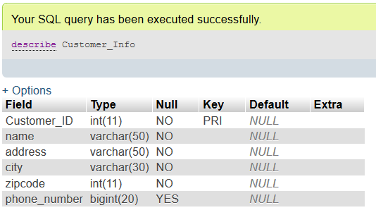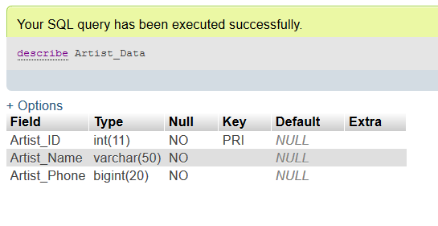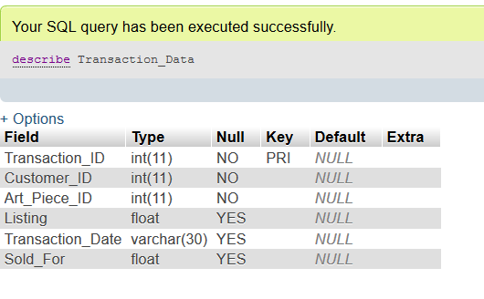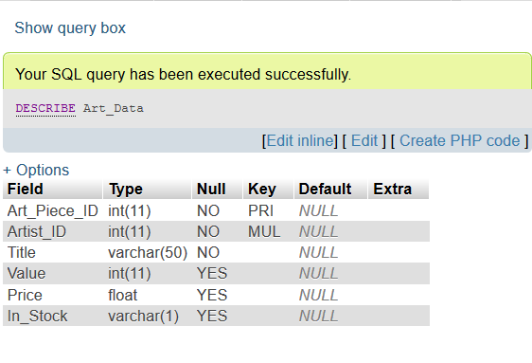

**Part 3:**

Load your tables with sample data – this is where you’ll have to be creative. I would like to see your databases have at least 8-10 customers, 5-6 artists and at least 15-20 pieces of art in the database.

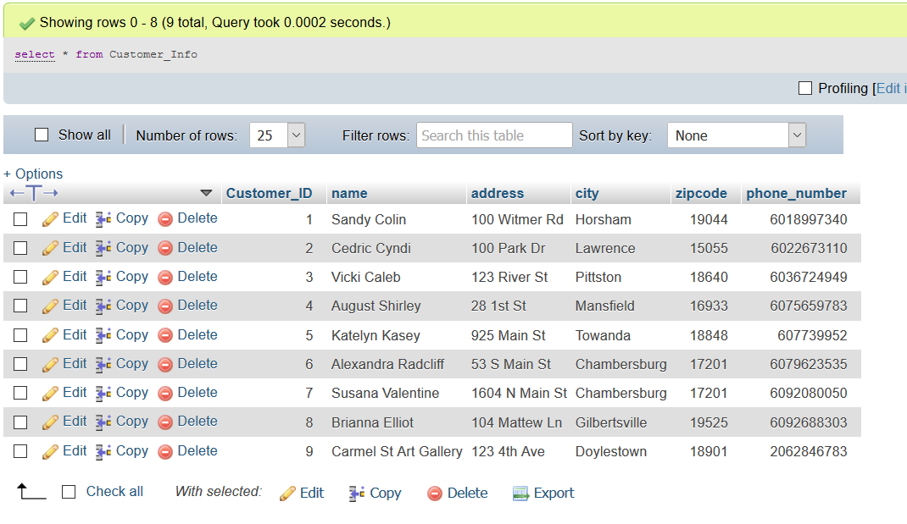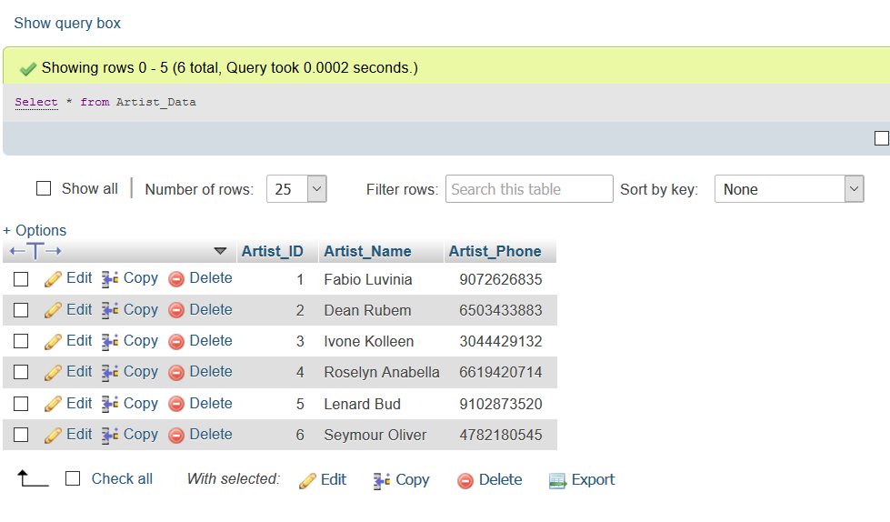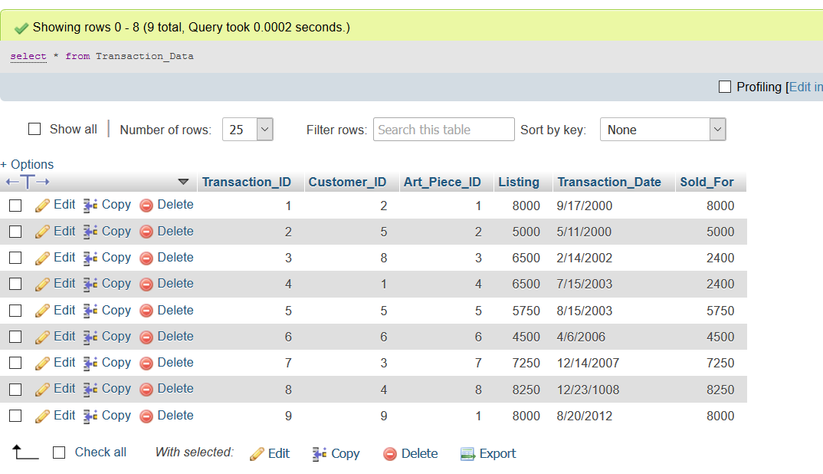

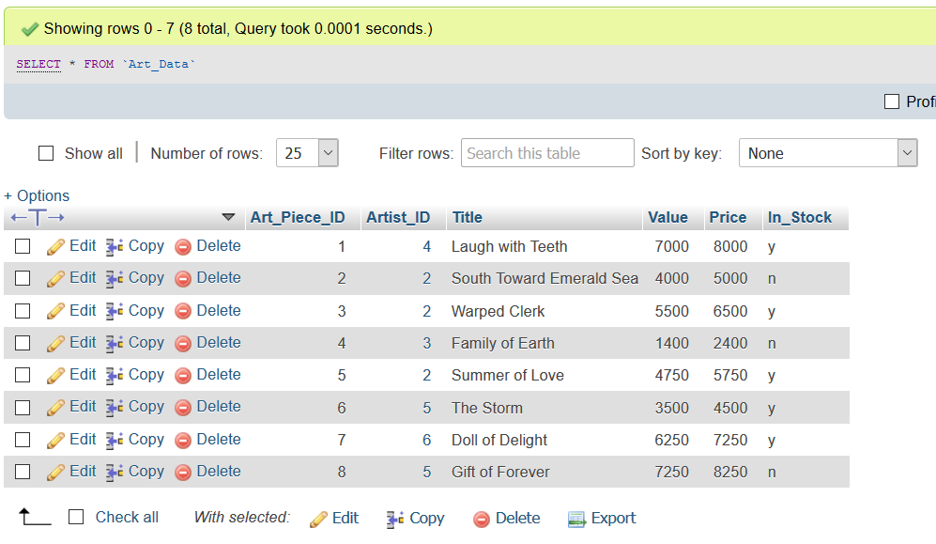

**Part 4 (queries)**

* **Provide a report of all of the art owned by all of customers, the report (or query) should include the owner’s name, the artist and the title of the artwork.**

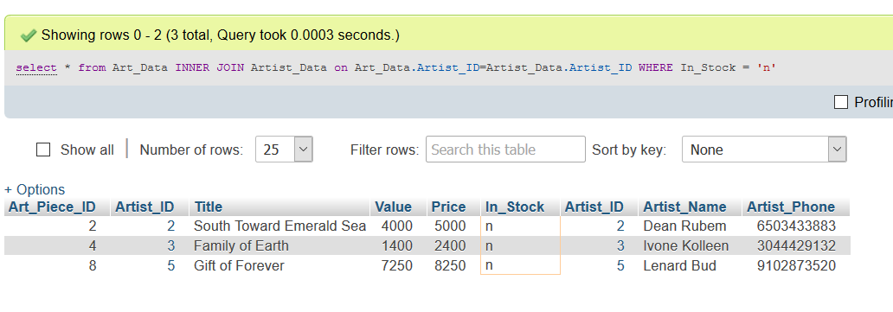

* **Provide a report of artists without any works in Inventory**



**See above, same SQL query for previous query applies to this one, as the art piece won’t be in stock if it’s not in inventory.**

* **Provide a report of which artists do not have works owned by any customers**

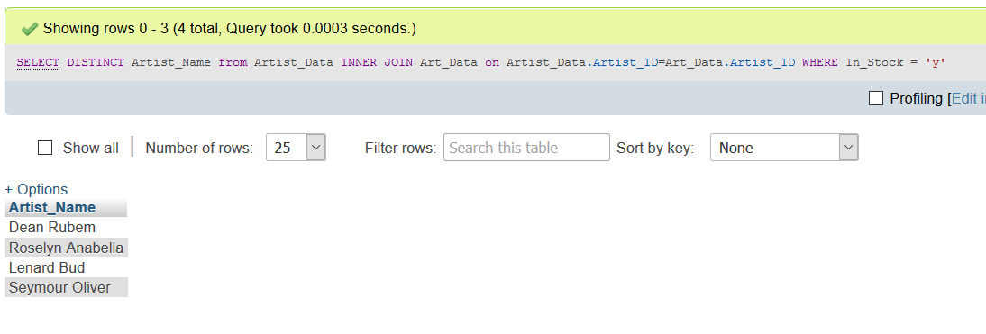

**Please include the SQL used for the queries**

**Part 5 (Tests)**

* Show an example of where you can NOT delete an artist from your tables

Due to constraints on the database

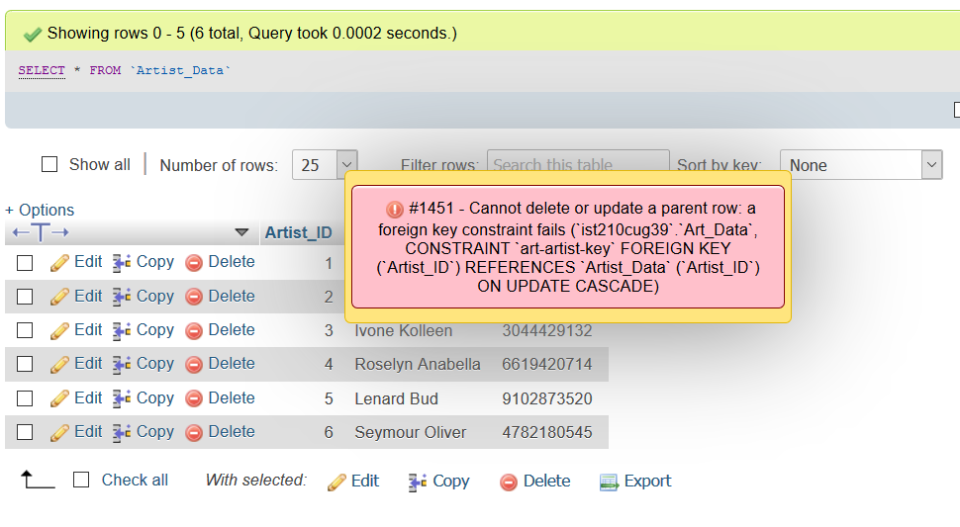

* Show that you can delete a particular piece of art from the database

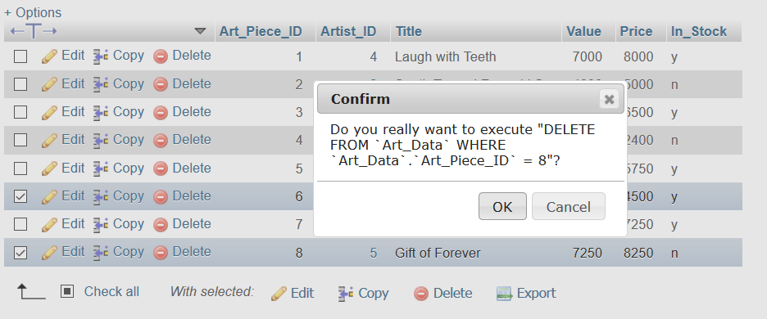

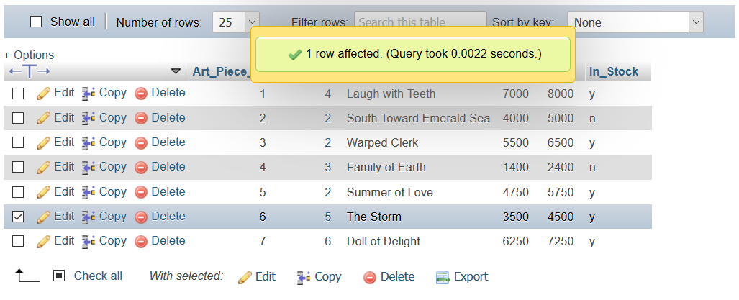

**Please include the SQL used for the queries**